OPERATIONAL AMPLIFIER APPLICATIONS -INVERTING SUMMING AMPLIFIERAND DIFFERENCE AMPLIFIER

**LAB # 08**



**Fall 2022**

**CSE-203L**

**Circuits & System-2 Lab**

Submitted by: **NAVEED AHMAD**

Registration No.: **22PWCSE2165**

Class Section: **B**

“On my Honor, as student of University of Engineering and Technology, I have neither given nor received unauthorized assistance on this academic work.”

Submitted to:

**Engr. Usman Malik**

11/12/2023

Department of Computer Systems Engineering

University of Engineering and Technology, Peshawar

**OBJECTIVE:**

* To demonstrate the use of Operational Amplifier for performing mathematical operations of summation and difference.

**EQUIPMENT AND COMPONENTS:**

* DC Power Supply
* Oscilloscope
* Function Generator
* LM 741 Op-amp
* 47kΩ
* 100kΩ

INVERTING SUMMING AMPLIFIER:

***THEORY:***

Figure 1 shows an example of how an operational amplifier is connected to perform voltage summation.

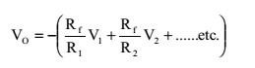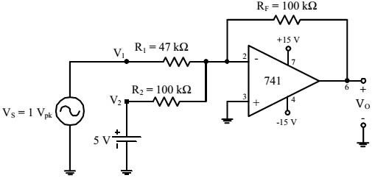

In this figure, an ac and a dc voltage are



summed. In general,



***Figure 1 inverting summing amplifier***

***PROCEDURE :***

* *To demonstrate the use of an operational amplifier as a summing amplifier, connect the circuit of Figure 1.*
* *With VS adjusted to produce a 1 V peak sine wave at 1 kHz, observe the output voltage VO (and VS to* note the phase relationship) on an oscilloscope set to dc input coupling.
* Sketch the output voltage waveform. Be sure to note the dc level in the output.
* Interchange the 5 V dc power supply and the 1 V peak signal generator.
* Repeat procedure step 2 and observe the change in output waveform.

DIFFERENCE AMPLIFIER:

THEORY OVERVIEW:

A difference amplifier has two inputs and the output voltage is proportional to the voltage difference of the input voltages. In fact, the (open-loop) Op-Amp itself is a difference amplifier, except that the gain is ideally infinity. Here we want a difference amplifier with finite gain. One such circuit using a single OpAmp is shown in Figure 4. It can be shown that the gain of the difference amplifier can be calculated using the following:

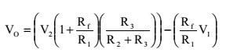

This equation can be simplified by making R3= Rf= R1= R2, yielding a simple differential amplifier with unity gain:

# V0=V2-V1

**Figure 2 showing difference amplifier**

Procedure:

* To investigate the use of an operational amplifier in a difference amplifier configuration, connect the circuit of Figure 2.
* With V S adjusted to produce a 1 V peak sine wave at 1 kHz, observe the output voltage VO (and VS to note the phase relationship) on an oscilloscope set to dc input coupling.
* Sketch the output voltage waveform. Be sure to note the dc level in the output.
* Interchange the 5 V dc power supply and the 1 V peak signal generator.
* Repeat procedure step 2 and observe the change in output waveform.

**Circuit and Figures:**

**Inverting Summing Amplifier:**

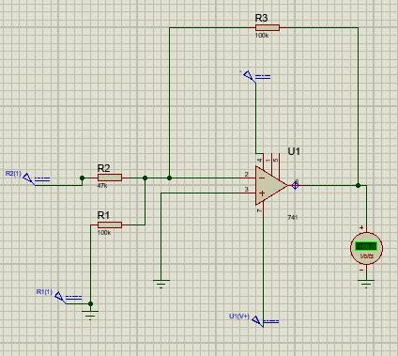

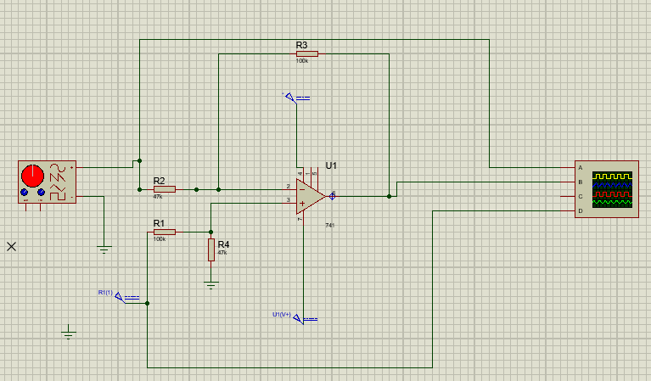

**Figures showing Difference Amplifier:**

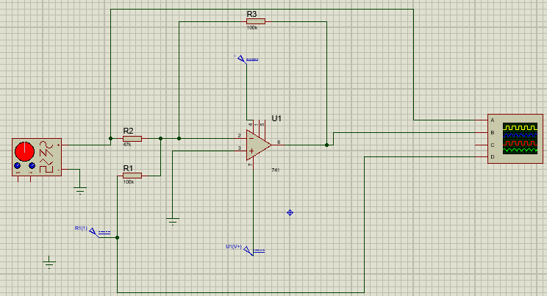

Figure showing difference amplifier

*Conclusion:*

*A summing amplifier can either be based on an inverting or non-inverting configuration. Despite the high input impedance and in-phase output signal that the non-inverting summing amplifier can provide, the inverting summing amplifier is more common as its output is a simple weighted sum.*

*Differential gain (AD) is the gain obtained at the output signal with respect to the difference in the input signal (V1 – V2) is applied. Therefore, we can conclude that the gain (AD) of the differential amplifier circuit which is made using Op-Amp is given by -(Rf/R1).*